[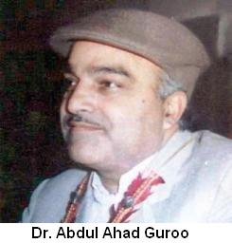](http://peacewatchkashmir.com/blog/2012/04/07/dr-abdul-ahad-guroo-by-abdul-majid-zargar/dr-guroo/)**Dr. Abdul Ahad Guroo**

**About:** Guroo became victim of one such covert operation.Dr. Guroo’s ,only fault was that  besides being a cardio vascular thoracic surgeon of national & international repute, he  was a human rights activist to the core. Since the onset of armed insurgency in the state in early 1989, he   rendered yeoman’s  service to those at the receiving end of the security forces whether as a Doctor or a human rights activist. He would bring instances of  grave human rights violations  in Kashmir to the notice of Various international forums .In fact a testimony by James Baker before the United Nations Security Council  in 1991 was based  entirely on evidences & supporting documents provided by Dr. Guroo.

**Murdered on:** 01 Apr 1993

**Attack details:** Dr. Guroo became victim of one such covert operation.

**Reason to him target:** April 1993 he was abducted by few gun totting boys near Soura while on way back home from his Hospital.

**Occupation:** Guru, a leading Srinagar Physician, who had founded a Medical College, had commanded wide respect; he presented a reasonable face of separatism. He was therefore, an inconvenience to the Police. The Police made an arrangement with the terrorist Zulkarnain, then in custody, who agreed to kill Guru in exchange for his release. But to ensure that this collusion remained secret, Zulkarnain was killed shortly thereafter and the Director General of Police, B.S.Bedi, trumpeted his death as a triumph for the security forces, who had killed a dangerous terrorist in an armed encounter. But the truth was somewhat different. Instead of killing Zulkarnain in an armed encounter, the police stormed the home where, under the mistaken presumption that he was safe after having fulfilled his end of the bargain, he was consorting with a lady friend.”

**URL:**<http://peacewatchkashmir.com/blog/featured/dr-abdul-ahad-guroo-by-abdul-majid-zargar/comment-page-1/>

